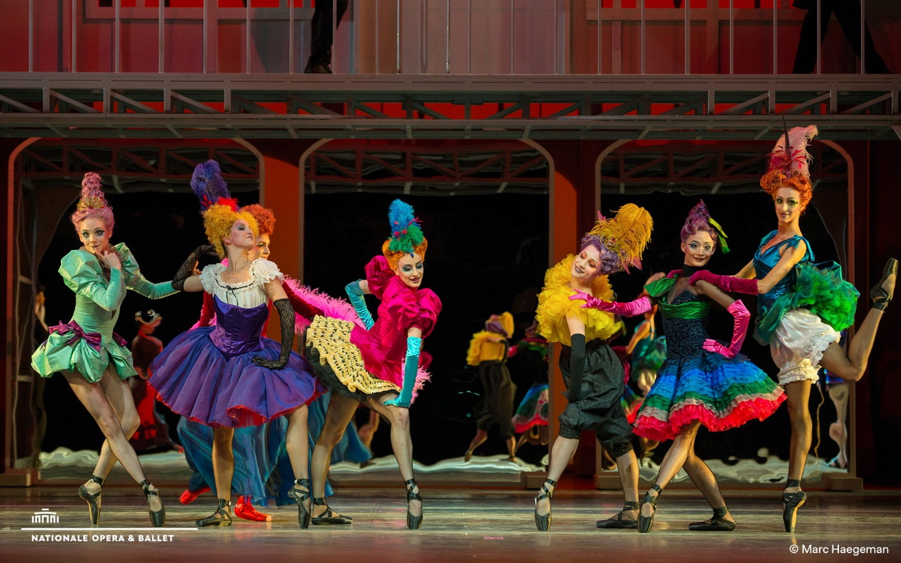

Dutch National Opera & Ballet is looking - temporarily for now - for a:
1st DRESSER BALLET
(fulltime , irregular working hours)
About us:
Dutch National Opera & Ballet is one of the largest Dutch cultural organizations and is located in the heart of Amsterdam. In our theatre, the magic is created on stage. With over 600 colleagues of 30 nationalities we work together every day to create opera and ballet productions. Every detail counts, which is why we value craftsmanship in every part of our organization.
Do you want to contribute?
About the function:
The regular 1st dresser is going on unpaid leave until the end of the season. She will no longer be doing the big Christmas production (Nutcracker & Mouse King). This means that we are looking for an immediate replacement. Preferably for someone who can come in for the whole period, but initially for someone who can be 1st dresser for the December production, which runs through January 2, 2022.
As first dresser, you will be responsible for ensuring that our dancers and extras look perfectly dressed, every performance.
Main duties include:
- preparing work schedules for dressers and extra dressers;
- distributing the work among the dressers and extra dressers;
- keeping track of mutations and checking the time worked;
- collecting the cast list for the show in question;
- allocating and preparing dressing rooms, costumes and accessories;
- assisting with dressing and changing dancers and the extras;
- organizing and carrying out quick changes of clothes in the wings or dressing rooms;
- collecting and checking costumes after the performance;
- cleaning and ironing of costumes and carrying out minor repairs;
- taking care of storage of clothing after a series.
This is a job with irregular working hours. Performances take place in the evening hours and/or on weekends and holidays. The coordinating tasks (making work schedules, contracting extra dressers, administrative processing) is something you can organize yourself.
Who we are looking for?
We are looking for a practical, organizational talent that can work under pressure. Together with the regular & freelance dressers, you form a team. You know how to create peace of mind for the dancers, because you work accurately with a sharp eye for detail and you are able to come up with appropriate solutions in case of problems. Our dancers often do not speak Dutch, so it is necessary that you speak English fluently. You are at the service of the whole, the performance. Adapting to what is needed and being there for your colleagues is only natural for you.
What we offer:
We would like to discuss with you how you will come to work for us. This is also possible on a secondment basis.
For more information about this position, please contact o.haller@operaballet.nl.
Enthusiastic?
Then apply as soon as possible via this link: https://werk.operaballet.nl/eng/vacaturebank/1e-kleder-ballet
Do you recognize yourself in the job profile? Then please respond. Dutch National Opera & Ballet embraces diversity and inclusion. Vacancies are open to everyone.

